Lab 3

Question 1

- List all hotels with hotel name and location
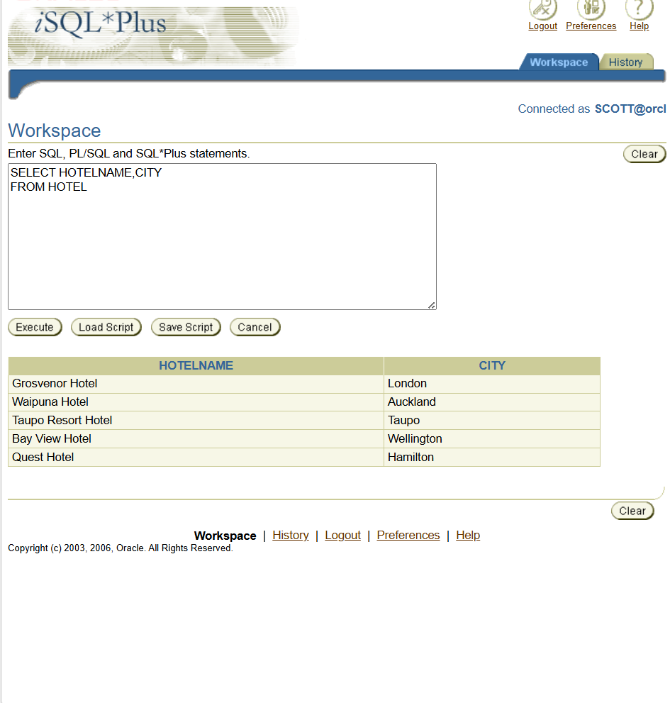

- Display full details of all guests

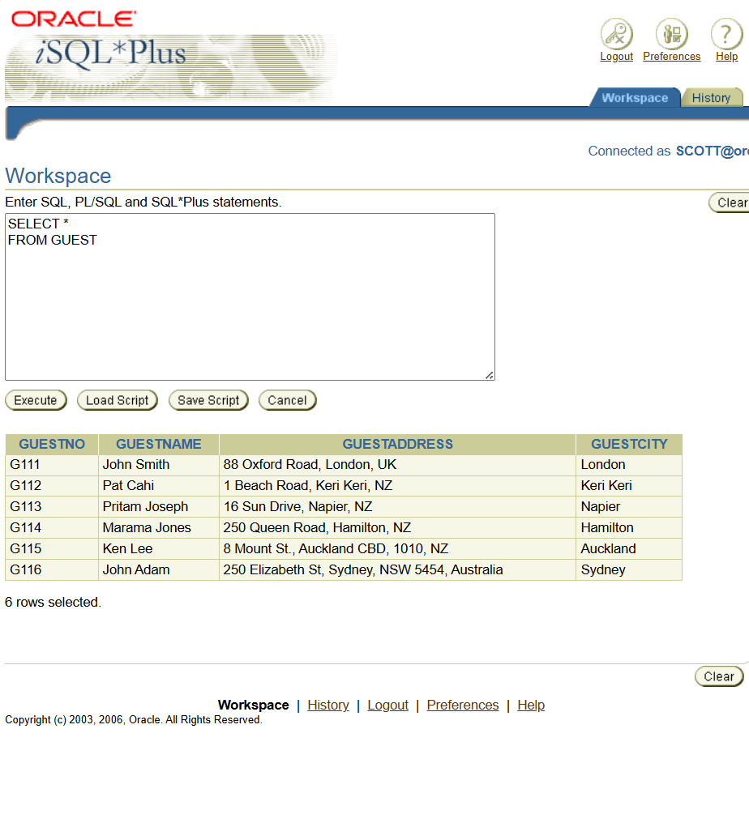

- Display room number and price of all Standard rooms

- Display name and address of guests who live in London
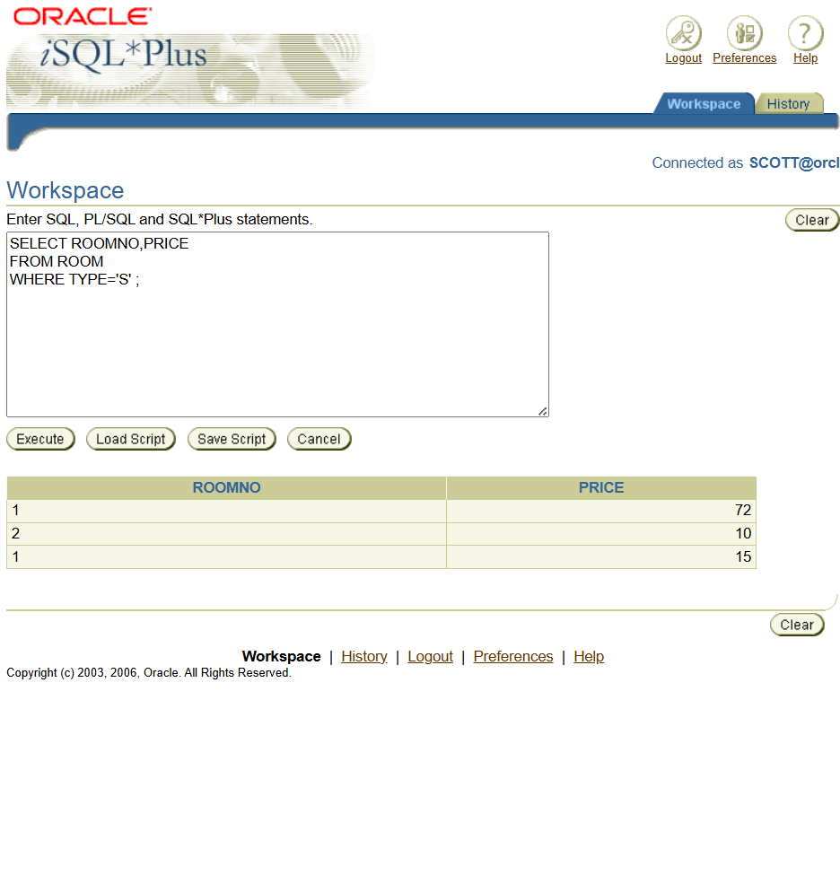
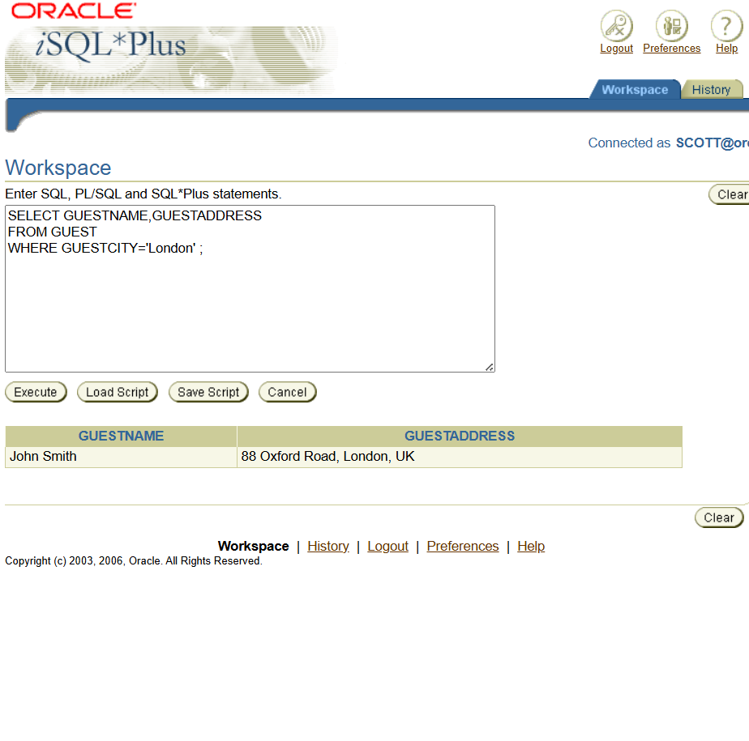

- List bookings for which NO dateTo has been specified

